# CS 255 System Design Document Template

## UML Diagrams

### UML Use Case Diagram

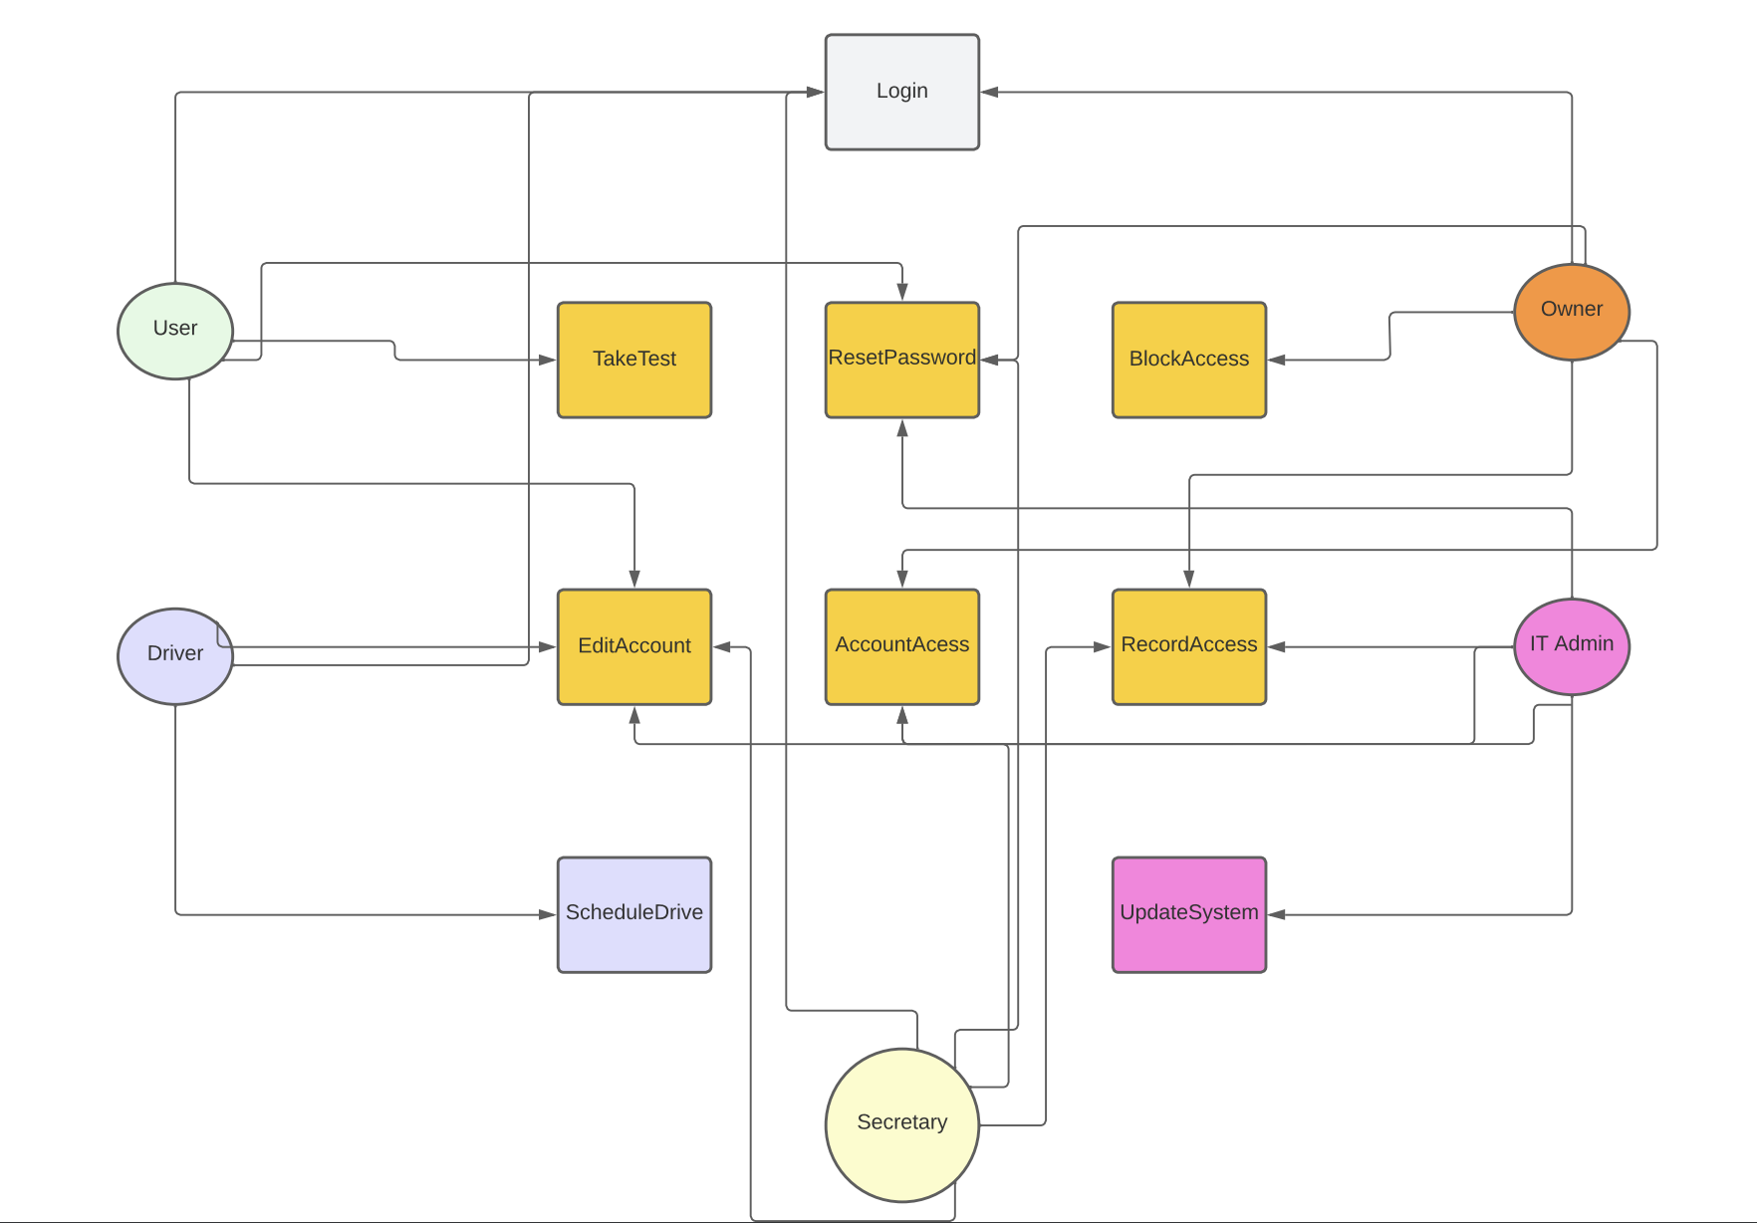

### UML Activity Diagrams

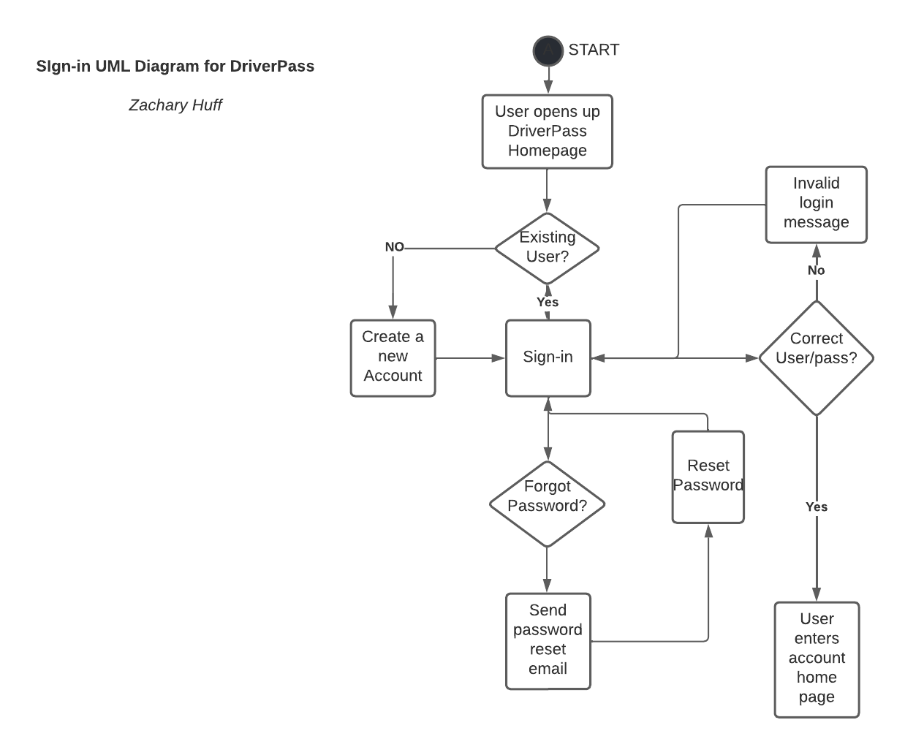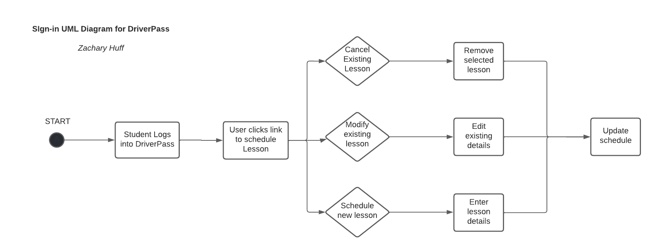

### UML Sequence Diagram

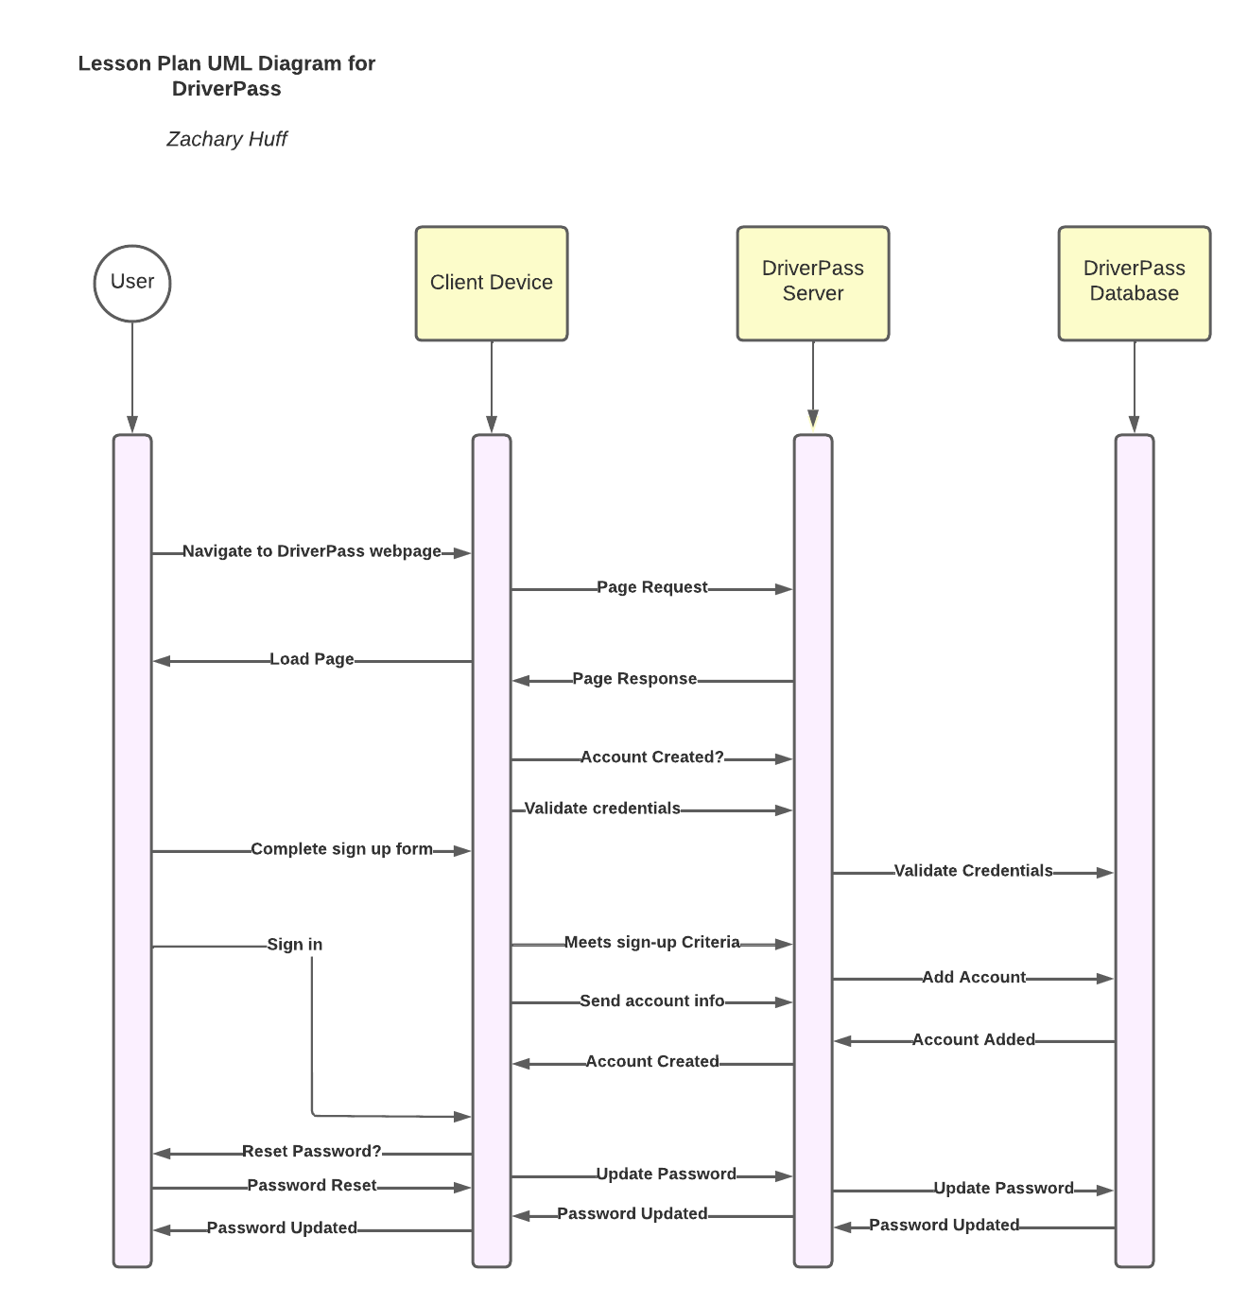

### UML Class Diagram

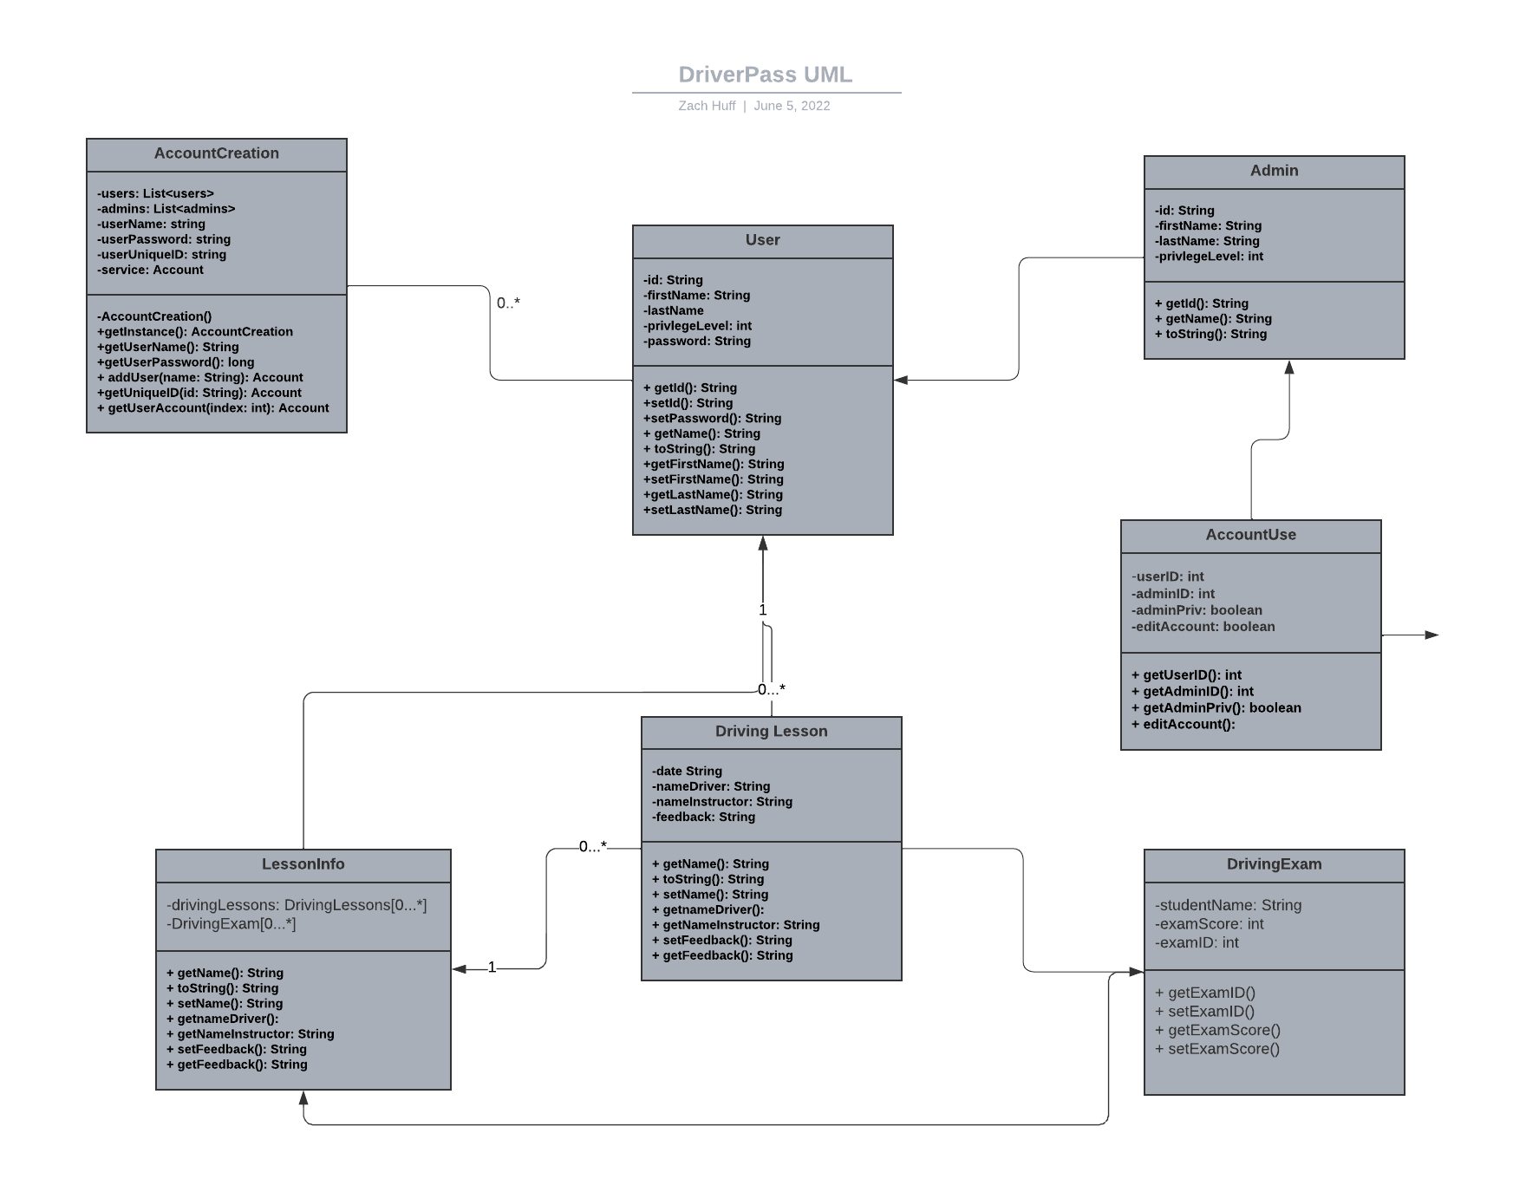

## Technical Requirements

*[Based on the diagrams you have created, describe the technical requirements of your system. These requirements should address the required hardware, software, tools, and infrastructure necessary for your system design.]*

Hardware needed for Client devices running DriverPass would be items such as:

* Smart Phone
* Laptop
* Desktop
* Tablet

Additional Servers would be needed for the website and cloud services.

Software would include all web browsers that are commonly used. An operating system of some kind: linux, windows, macOS, android, iOS. It would be the main OS’s that are supported. A server OS would be needed as well whether it be windows server or Linux.

Tools:

* Lucid Chart
* IDE for programming
* Development of computers
* Development Stack (front-end, back-end etc)

Infrastructure:

* High Speed Internet
* Mobile internet access
* WIFI